Courtney Thurston

AP Art History

Mrs. Eckel

Byzantine Art

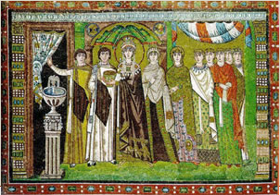

The work of art depicted above is of the Empress of Byzantium at the time, Theodora (wife of Justinian I), and her servants. First and foremost, the opulence of the period of Byzantine art is reflected in this work of art, which is a mosaic housed within the Basilica of San Vitale. Dating back to approximately the sixth century, this mosaic was painstakingly created by an artist or artist(s). Secondly, the various colors contribute to the eye-catching nature of this mosaic—attention that Justinian I loved and felt as though he and his empire deserved. Third and finally, this work of art reflects the importance of religion to the empire—there are multiple religious allusions throughout the mosaic, such as the bowl of water (symbolizing forgiveness and cleanliness from the filth of sin).